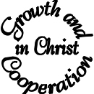Draft Agenda for Synod Meeting 17th Sept 2003
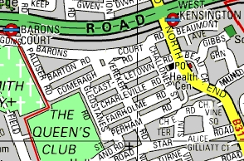
Wednesday 17th Sept 2003 at St Andrew’s Fulham Fields
The Church is between St Andrew’s Rd and Star Road. The nearest tube stations are Baron’s Court and West Kensington. Parking is very difficult
hfd.org.uk

19:45 Arrival Coffee etc.. available
20:00 1. Welcome, Devotions
20:05 2. Minutes of 12th June
Please email any suggested corrections in advance if possible.
20:07 3. Matters Arising. (not otherwise covered)
3.1 Any feedback on Wormwood Scrubbs? (Item 3.1 of 12th June)
20:10 3.2 St John’s Glenthorne Rd (Item 3.3)
20:15 3.3 Central Fulham (Item 3.4)
20:20 3.4 Community Chaplaincy (Item 3.5)
20:22 3.5 any others?
20:30 4. Deanery Mission Action Plan - Growth
4.1 Summary of Roll Growth The figures for Roll Growth between the APCMs in 2002 and 2003 are encouraging: with 11% growth overall and some parishes growing at over 40%!
20:35 4.2 St Andrew’s growth from 02-03 – Presentation
20:45 4.3 – Discussion
20:55 4.4 – Feedback
21:05 4.5 Report on Common Fund progress and process
21:10 4.6 Report on ‘'Resourcing Mission and Ministry' document
21:15 5. Deanery Mission Action Plan – Cooperation
5.1 Hope in H+F report (5)
21:20 5.2 Soul in the City: feedback and progress (5)
21:25 5.3- School governorships (5)
21:30 6. Notices from the Chair
21:35 7. AOB (submitted to Chairs and Sec at least 24hrs beforehand. Please EMail secretary@hfd.org.uk)
21:37 9. Closing devotion.
21:40 Conclusion
Please note that the Attendance Sheet is at the back of the Church. All you have to do is tick off your name as being present. You’re also asked to tick if you are happy for your name and email address to be available to other Synod Members. It will really help us all communicate if people can do this. Alternatively please email your consent to secretary@hfd.org.uk

