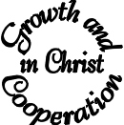Draft Agenda for Synod Meeting 12th June 2003
Thursday 21 June 2003 at St Katherine’s, Westway (Primula Street W12)
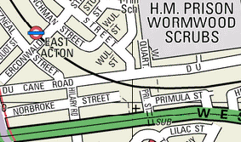
hfd.org.uk

19:45 Arrival Coffee etc.. available
20:00 1. Welcome, Devotions
20:05 2. Minutes of previous meetings: 19th March
20:07 3. Matters Arising. (not otherwise covered)
3.1 Any feedback on Wormwood Scrubbs? (Item 8 of 19th March)

20:10 4. Deanery Mission Action Plan This Mission Action Plan (or MAP) defines the objectives that we aim to pursue for the next three years. The focus is Growth and Cooperation in Christ. A revised (even shorter) copy of this plan is on the reverse of this agenda. Please make sure you have read it before the meeting. [Led by the Deanery Standing Committee]
20:30 5. Soul Survivor Presentation This is related to Hope for Hammersmith and Fulham.
21:00 6. Denaery Exchange
21:15 7. Remarks and notices from the Chair
21:25 8. AOB Must be submitted to Chairs and Sec 24 hrs beforehand. Please EMail nb@sciteb.com if you have any.

21:35 9. Closing devotion.
21:40 Conclusion

Please note that the Attendance Sheet is at the back of the Church. All you have to do is tick off your name as being present.
You are also asked to tick if you are happy for your name and email address to be available to other Synod Members. It will really help us all communicate if people can do this. Alternatively please email your consent to secretary@hfd.org.uk

